Internship Report

Bachelor Of Technology
in
Birla Vishvakarma Mahavidyalaya
By
Yash Vala
(19CP057)



DEPARTMENT OF COMPUTER ENGINEERING
BIRLA VISHVAKARMA MAHAVIDYALAYA

Company Name: Education 4 ol
Task: Online payment system
Duration: 1st June 2021 to 1th July 2021

Contents

- Acknowledgement and offer latter ……………………………… 3

- Abstract and completion certificate………………………………. 4

- Objective and star performer certificate………………………. …. 5

- Functionality....……………………………………………………. 6

- Implementation of work…………………………………………… 7

- Overview of work day wise..……………………………………….8

- Screenshot ........…………………………………………………… 9

- Conclusion ……...………………………………………………... 13

- Reference ...………………………………………………………. 13

Acknowledgment

- I wanna thank the CEO of Education 4 ol Mr. Audumber Chaudhari sir for providing us such amazing opportunity to enhance and to sharp our skills by this internship.
- I thank my college faculties and counselor for helping in this and provide us these opportunity.
- Furthermore , I extend my warm gratitude and regards to everyone who helped me during my internship

OFFER LETTER



Abstract

I have completed my 1 month internship at Education 4 ol .

Education 4 ol is working to bring parity in education, making sure children have equal opportunity at success.

During this 1 month of internship, I was select as Front end web developer position. I was given a task to make a front end for online payment gateway. One will be able to do transaction using this gateway. The main motive was to get knowledge of front end web development

Tech stack : HTML, CSS, java-script

Completion Letter
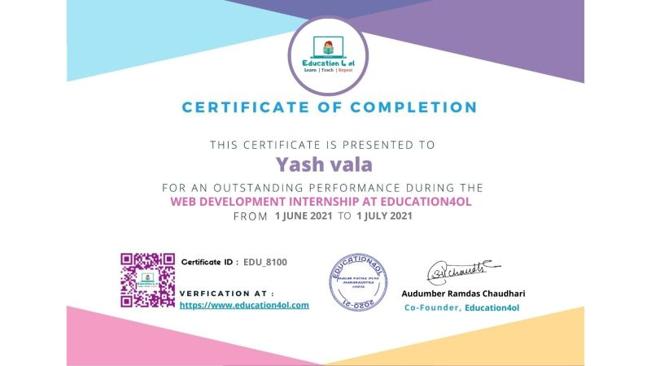

Objective
➢ Internships are generally thought of to be reserved for college students looking to gain experience in a particular field. However, a wide array of people can benefit from Training Internships in order to receive real world experience and develop their skills.
➢ An objective for this position should emphasize the skills you already possess in the area and your interest in learning more
➢ Internships are utilized in a number of different career fields, including architecture, engineering, healthcare, economics, advertising and many more.
➢ Some internship is used to allow individuals to perform scientific research while others are specifically designed to allow people to gain first-hand experience working.
star performer
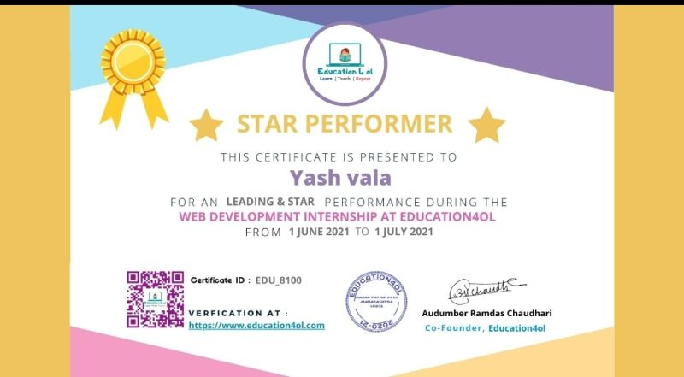

FUNCTIONALITY
- I developed Front end for the online payment system.
- Methods for online payment system:
- UPI
- Credit Card
- Debit Card
- Card number, Card holder’s name, Expiry date, CVV numbers are needed to given by user for Credit card and Debit card option.
- For UPI option user needs to give its UPI ID and needs to selected UPI app.
- After giving details, user is navigated to OTP verification page where user needs to enter OTP.
- I use pure CSS for animations
- After successful payment, payment details are shown.
Payment details include transaction_id, Date, Amount.

Implementation of work

- Whole internship was divided into two tasks.

- Task1 - Design payment system Front End:
- Initiating the simple payment page (where we are gonna ask user, name, UPI Id, etc.)
- verifying opt page (where user can enter the OTP for the verification)
- Duration: 15 days

- Task2 - Design Success and Rejection pages:
- Design payment Success page details of transaction.
- Design payment Rejection/fail Page.
- Duration: 15 days

AN OVERVIEW OF ACTIVITY DURING THE MONTH
Started: 1/6/21.
Date | Day | Work Carried out
1/6/21 | Tuesday | Got our project brief
2/6/21 | Wednesday | Did research by visiting existing online payment system.
3/6/21 | Thursday | Continued the research
4/6/21 | Friday | Gathered information need for credit card, debit card, UPI payment.
5/6/21 | Saturday | Started designing UI in figma
7/6/21 | Monday | Build Home screen UI design
8/6/21 | Tuesday | Build Credit card screen UI design
9/6/21 | Wednesday | Build UPI payment screen UI design
10/6/21 | Thursday | Learning animation using pure css
11/6/21 | Friday | Create animation using pure css
12/6/21 | Saturday | -
14/6/21 | Monday | Fix small animation bugs
15/6/21 | Tuesday | Representation regarding task -1
16/6/21 | Wednesday | Created Home Screen for task 2
17/6/21 | Thursday | Created Credit card and debit card screen with validation.
18/6/21 | Friday | Created UPI Screen with validation.
19/6/21 | Saturday | Created transaction status screen with animation.
20/6/21 | Sunday | -
21/6/21 | Monday | Added animation to before home screen.
1/7/21 | Thursday | Uploaded Projec

Screen shots

Home Screen
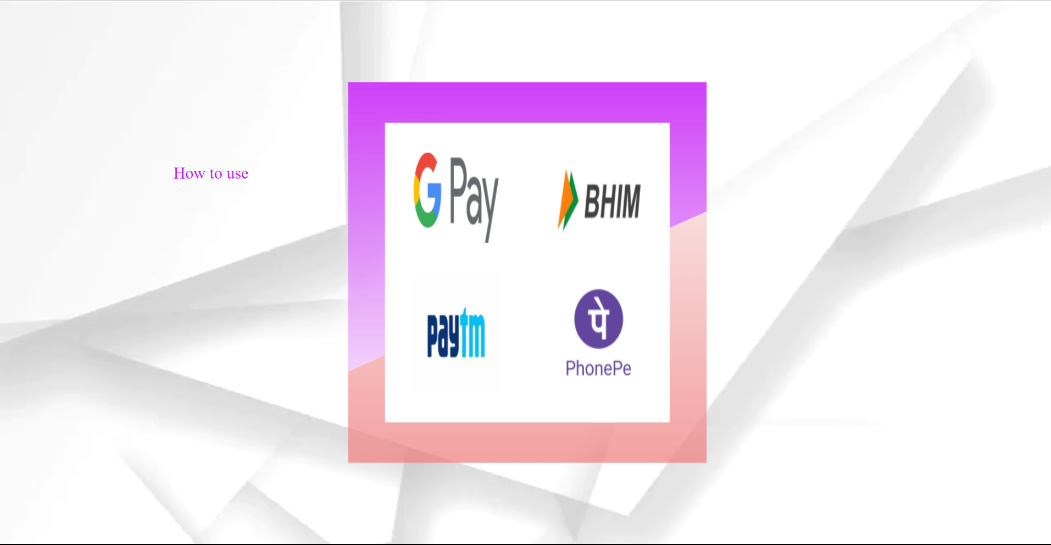

Welcome screen

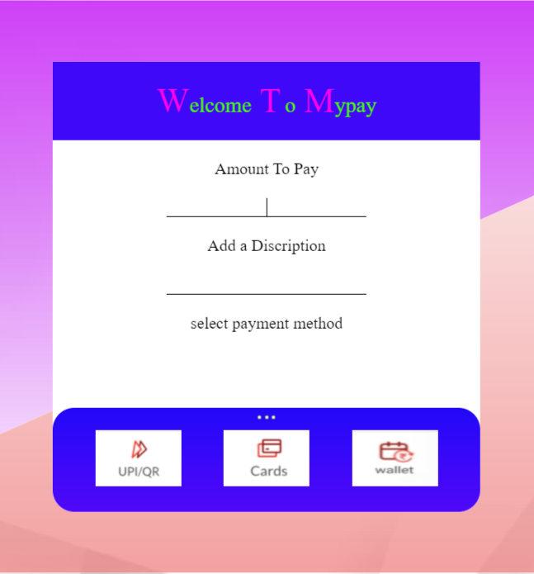

Card detail Screen
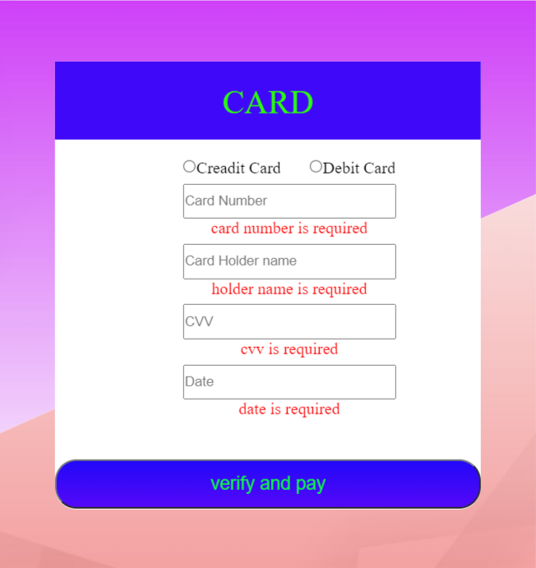

OTP Screen
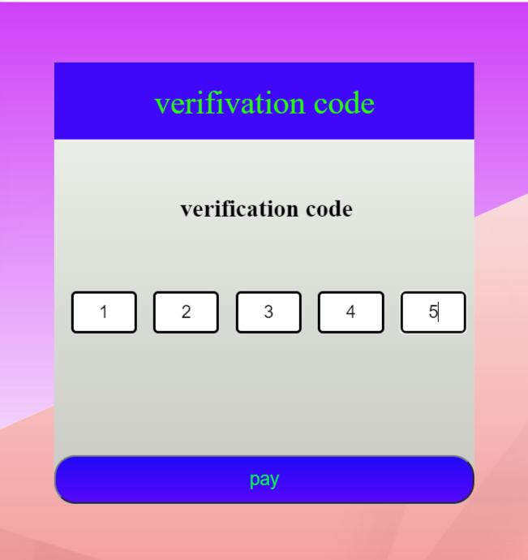

waiting Screen


Successful Transaction Screen
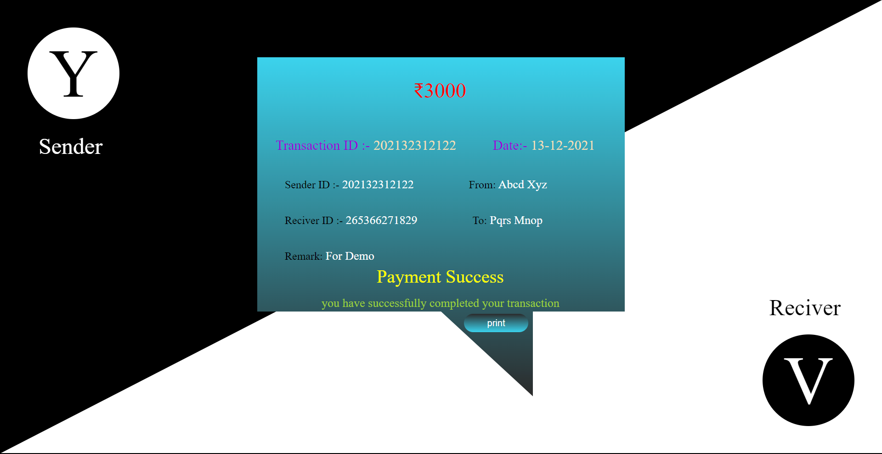

Failed Transaction Screen
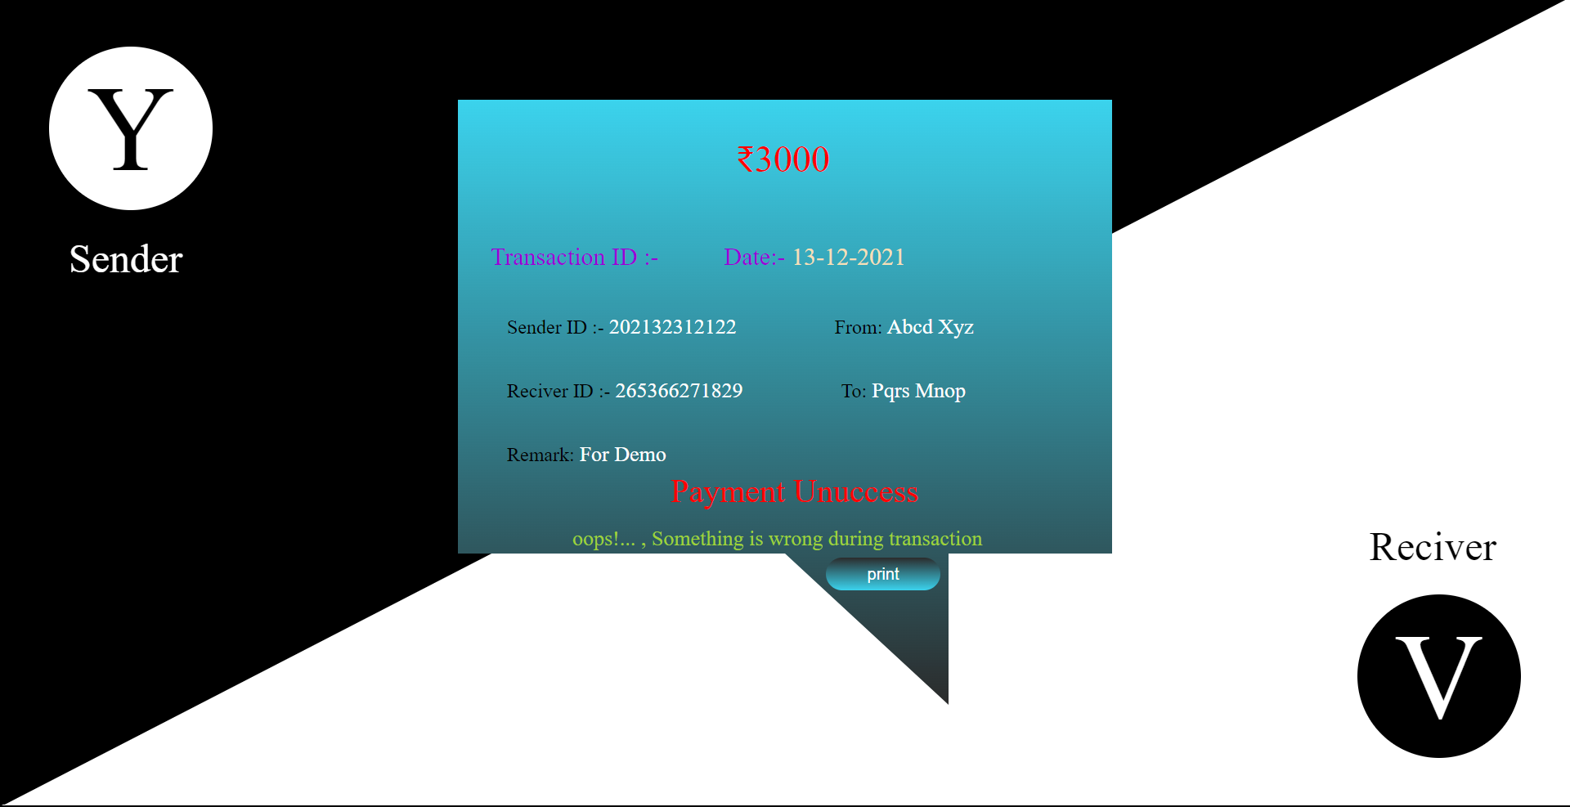

Conclusion

- I get to learn pure CSS for animations.
- I get to learn how to build front end web site using HTML, CSS, JavaScript, Bootstrap.
- How to create user friendly interface.
- Steps followed by company for web-development front end

REFERENCES

- W3schools : beginner friendly tutorial in HTML, CSS, PHP.
- YouTube

